# Exercise

#### CSV and DataTable

Store the below data in a .csv file. First row has the column names. Read the CSV file in your automation and return values where the ‘Suspicion’ values are greater than a given Suspicion number. Get the Suspicion number from the user using a drop-down choice list of values from 0 to 9.

#### Word,Suspicion

chapter,2 bark,3 UiPath,1 Fantastic,4 dark,0 John,2

Congratulations,6 ear,2

penny,1 bleeding-edge,4 encryption,2 that,4

you,6 asterisk,1 Blue,3

Demolition,2 have,7 goober,1 details,4 show,0 completed,8 Symphony,1 foundation,2 avenging,3 crunch,3 absurdly,4 this,9

easy,4 zero,2 exercise,9

|  |  |  |
| --- | --- | --- |
| **Area** | **Hint** | **Level** |
| CSV,  DataTable | Read CSV, DataTable, DataTable.Select(), DataRow,  Array Processing … | **Simple** | Medium | Complex |

# Solution

1. 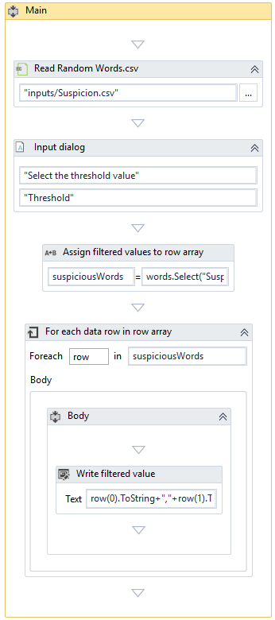Overall Workflow:

Let’s build the workflow step-by-step:

1. Create a folder named ‘inputs’ in the base folder of your UiPath project. Create a file inside the ‘inputs’ folder with a name, say, ‘Suspicion.csv’ and save the data provided in the problem statement in this file.
2. Create a ‘Sequence’ File by clicking on “DESIGN→New→Sequence”. Enter name ‘CSVAndDatatable’.

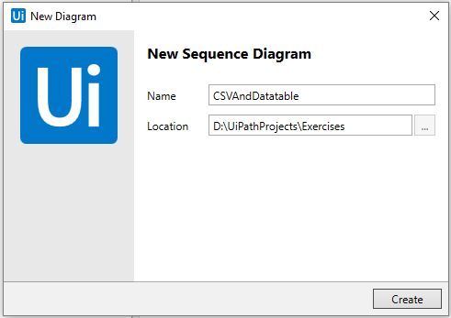

1. 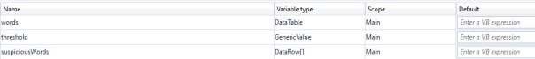Create variables:
2. 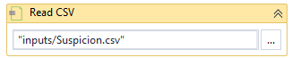Add an activity ‘Read CSV’

Enter the variable ‘words’ of type DataTable in the Properties Panel for the Output property ‘Data Table’:

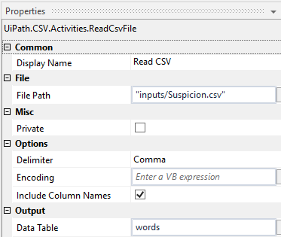

1. 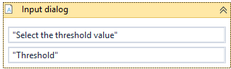Add ‘Input Dialog’ activity:

To use ‘Input dialog’ as a dropdown-based choice selection UI, add a string array as shown below under ‘Options’ property. These values are the threshold values possible in a Suspicion Words list. Save the value selected at the runtime by the user in a variable ‘threshold’:

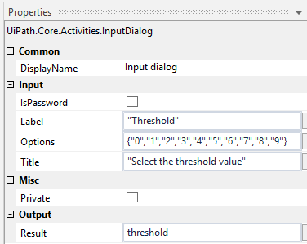

1. DataTable provides a method named ‘Select’ that can be used to filter the data based on a query. Here we are interested to show all the words that have suspicion value equal to or more than the threshold value selected by the user:

The query for the ‘Select’ method is shown below:

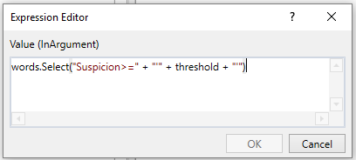

The ‘Select’ method on the datatable object returns all the rows that match

the query. This is returned in the form of an array of DataRow i.e. DataRow[].

1. To process the DataRow[], we can use generic ‘For Each’ loop.

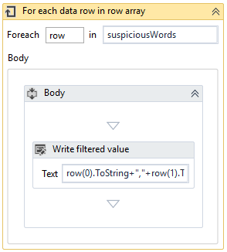

In the properties panel for the ‘For Each’, select the TypeArgument as System.Data.DataRow. This will tell the For Each loop as what is the type of each item in the array you are processing.

## UiPath

### Robotic Process Automation Practice Exercises

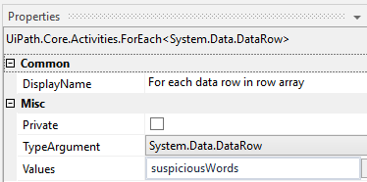

Simply display the words using ‘Write Line’ activity in the ‘For Each’ Loop

body:

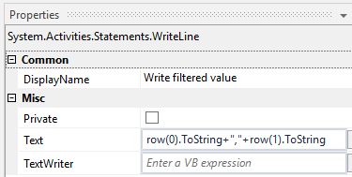

1. 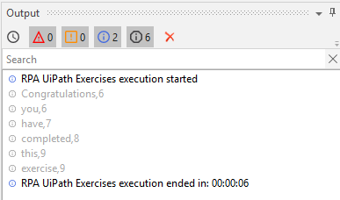Output will be shown in the Output panel:

DONE. Now, run the workflow to test it.

--x--